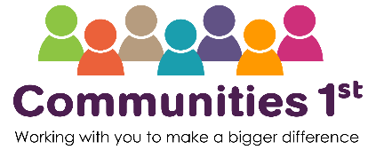

Training Terms & Conditions

Bookings
In order to help keep the cost of training to a minimum, all bookings must be made online - we cannot accept telephone bookings, unless you do not have internet access or have a specific need which prevents you from being able to book online. Where possible, payment should be made on-line at the time of booking. In cases where an invoice is required, payment is still required prior to the start of the course. We are unable to reserve places in advance of bookings. Communities 1st reserves the right to cap the number of places allocated per organisation for courses which are especially in demand.
We will send a confirmation email once your booking has been processed. Please let us know if you have not heard from us within 10 days after submitting your form. We cannot accept responsibility for non-arrival of this information and you will only be able to attend a course once you have received written confirmation and full payment has been made. If you have any queries relating to your booking email training@communities1st.org.uk.
Cancellations
It is important to us that as many people as possible benefit from our training. If you register for a course and then cancel your place, particularly at short notice, you may have prevented someone from attending. Please let us know as soon as possible if you cannot attend a course. If someone else is attending in your place, please email us to inform us of this.
For cancellations made more than 21 days before the course date there will be no charge. For cancellations made between 21 and 14 days before the event, there is a 50% charge, and if made with less than 14 days’ notice the full course fee will be charged. There are no refunds if a learner, or replacement learner, fails to attend a course.
Communities 1st reserves the right to withdraw a course at any time. In these
circumstances, participants will be offered an alternative course or date, if
applicable

